Grain Nutrition Facts Per 1 cup raw grain (minimal nutrients are lost with baking)
Nutrients | Hard Red  Wheat | Hard White | Soft Wh.  Wheat | Spelt | Barley | Oats | Quinoa | Millet
Calories | 628 | 657 | 571 | 588 | 704 | 607 | 626 | 756
Carbs | 137 g * | 146 | 127 | 124 | 155 | 103 | 109 | 146
Fiber | 23.4g | 23 | 21.3 | 18 | 31.2 | 16.5 | 11.9 | 17
Fat  Omega 3  Omega 6 | 51.8 mg  1152 mg | 3.283  67.2  1373 | 60  1344 | 113mg  2076 | 110  1010 | 173  3781 | 522  5061 | 236  4030
Protein | **24.2g | 21.72 | 18 | 25.4mg | 19.8 | 26.4 | 24 | 22
Vitamin A | 17.3 IU | 0 | 15 iu | 17.4 | 44 | 0 | 23.8 | 0
Lutein &  Zeaxanthin | 422 mcg | 422 mcg |  |  |  |  | 277 | 0
Beta  Carotene | 9.6 mcg | 9.6 |  |  |  |  | 13.6 | 0
Vitamin E | 1.9 mg | 1.94mg | 1.7 | 1.4 | 0 | 0 | 4.1 | 0.1
Vitamin K | 3.6mcg | 3.6mcg | 3.2 | 6.3mcg | 4.4 | 0 | 0 | 1.8
Thiamine (B1) | 0.7mg | .743mg | 0.7 | 0.6 | 0.4 | 1.2 | 0.6 | 0.8
Riboflavin (B2) | 0.2mg | 0.2mg | 0.2 | 0.2 | 0.2 | 0.2 | 0.5 | 0.6
Niacin (B3) | 10.5mg | 8.4mg | 8.0 | 11.9 | 9.2 | 1.5 | 2.6 | 9.4
B6 | 0.6mg | 0.7mg | 0.6 | 0.4 | 0.5 | 0.2 | 0.8 | 0.8
Folate | 73mcg | 73mg | 68.9 | 78.3 | 46 | 87 | 313 | 170
B12 | 0 | 0 | 0 | 0 | 0 | 0 | 0 | 0
Pantothenic  Acid (B5) | 1.8mg | 1.8mg | 1.4 | 1.9 | 0.6 | 2.1 | 1.3 | 1.7
Choline | 59.9mg | 0 | 0 | 0 | 75 | 0 | 119 | 0
Betaine | 0 | 0 | 0 | 0 |  | 0 | 1072 | 0
Calcium | 55.7mg | 61 mg | 57.1 | 47 | 58 | 84.3 | 79.9 | 16
Iron | 6.1mg | 8.76 | 9.0 | 7.7 | 5 | 7 | 7.6 | 6
Magnesium | 242 mg | 178 | 151 | 237 | 158 | 276 | 335 | 228
Phosphorus | 553mg | 681 | 675 | 698 | 442 | 816 | 777 | 570
Potassium | 697mg | 829 | 731 | 675 | 560 | 669 | 957 | 390
Sodium | 3.8mg | 3.84 | 3.4 | 13.9 | 18 | 3.1 | 8.5 | 10
Zinc | 5.1mg | 6.39 | 5.8 | 5.7 | 4.3 | 6.2 | 5.3 | 3.4
Copper | 0.8mg | 0.7 | 0.7 | 0.9 | 0.8 | 1.0 | 1.0 | 1.5
Manganese | 7.7mg | 7.3 | 5.7 | 5.2 | 2.6 | 7.7 | 3.5 | 3.3
Selenium | 136mcg | 0 | 0 | 20.4 | 75 | 0 | 14.4 | 5.5
RDA (Recommended Daily Amount of Vitamins for women over 50
B1 Thiamine | 1.1 mg Day
B2 Riboflavin | 1.1 mg day
B3 Niacin | 1.1mg Day
B5 Pantothenic Acid | 5mg
B 6 | 1.9mg
B7 Biotin | 30 mcg
B9 Folate | 600mcg
B12 | 2.6mcg

Carbohydrate of Hard Red Wheat *zero fructose, sugar 0.8g.
**Amino Acid profile of Hard Red Wheat ---Protein24.2g48% Tryptophan307mg Threonine701mg Isoleucine879mg Leucine1639mg Lysine643mg Methionine386mg Cystine618mg Phenylalanine1137mg Tyrosine743mg Valine1067mg Arginine1142mg Histidine547mg Alanine864mg Aspartic acid1229mg Glutamic acid7677mg Glycine1014mg Proline2475mg Serine1125mg Hydroxyproline
Read More https://nutritiondata.self.com/facts/cereal-grains-and-pasta/5737/2#ixzz7OB56iDuW
Zero FRUCTOSE—

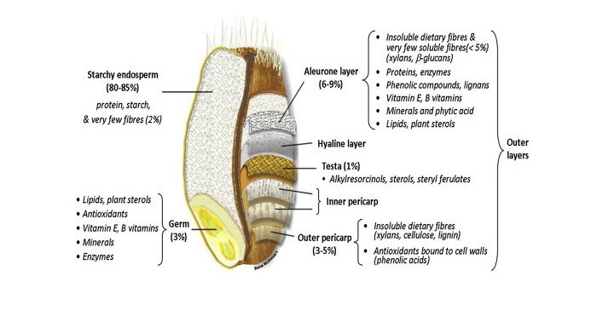
References:
https://nutritiondata.self.com/facts/cereal-grains-and-pasta/5679/2
https://www.healthline.com/nutrition/cooking-nutrient-content#roasting-and-baking
https://www.researchgate.net/profile/Vincent-Van-Buul/publication/253234051/figure/fig2/AS:269679973367809@1441308124210/Histological-structure-of-wheat-grain-Adapted-from-Barron-etal-2007-showing-bioactive.png

